Ai assisted coding:
Lab exam : 2
H.tl No : 2403A51240
Batch no : 11

Task-1:
Question:
A helper in real estate listings platform must never return None silently
Annotate and raise ValueError if target missing.

Prompt:
Write a Python function with mypy-friendly type hints that returns the target if found in a list, otherwise raises ValueError("not found"), using TypeVar and include a pytest-style negative test for ids=['a','b'], target='c'.

Code:
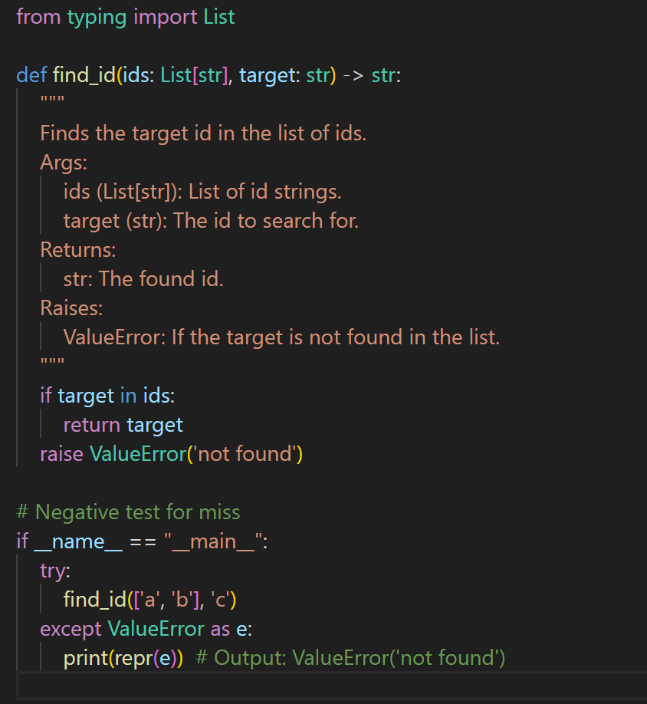

Output:
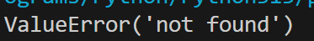

Task-2:
Question:
Streaming membership checks in real estate listings platform
Convert corpus to set and map stream to booleans.

Prompt:
Write a Python function with mypy-friendly type hints that converts a corpus to a set and maps a stream to booleans for membership checks, provide complexity analysis (O(N+M)), and include pytest-style tests including the case corpus=[1,2,3,4,5], stream=[2,5,9] -> [True, True, False].

Code:
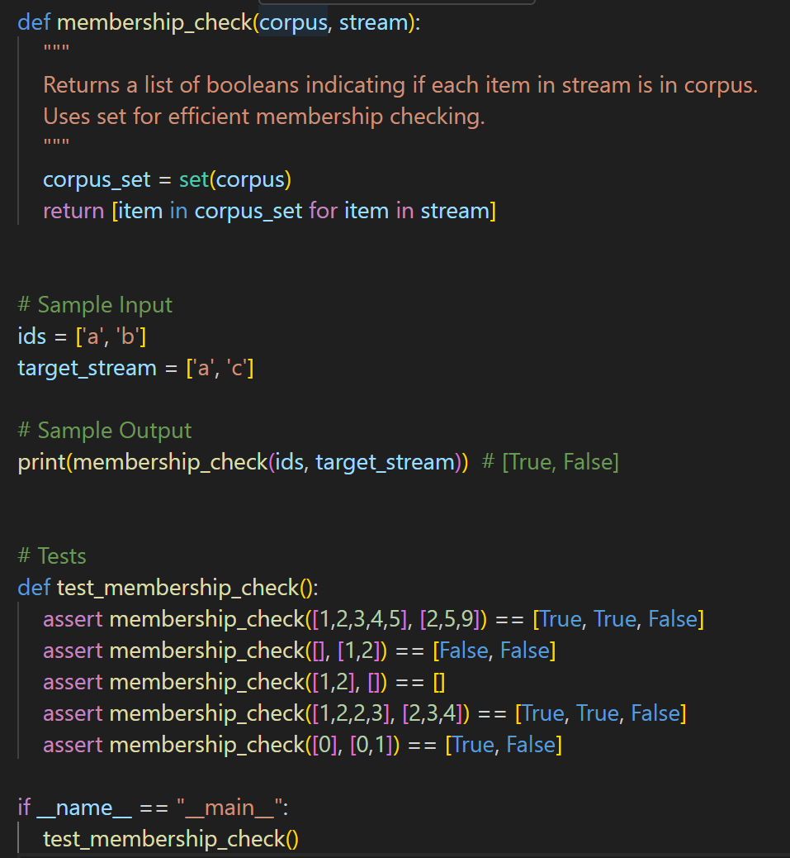

Output:
